Advanced DAX Notes (Power BI)
1. CALCULATE Function (Deep Dive)
What is CALCULATE?
CALCULATE() is the most powerful DAX function. It modifies the filter context and then evaluates an expression.
Syntax
CALCULATE(
Expression,
Filter1,
Filter2
)
Example Dataset
Product | Category | Sales
Laptop | Electronics | 50000
Mobile | Electronics | 30000
Chair | Furniture | 15000

Example 1: Total Electronics Sales
Electronics Sales =
CALCULATE(
SUM(Orders[Sales]),
Orders[Category] = "Electronics"
)
Result = 80,000
Steps
- Go to Modeling
- Click New Measure
- Enter DAX formula
- Use measure in visuals
Visual Representation
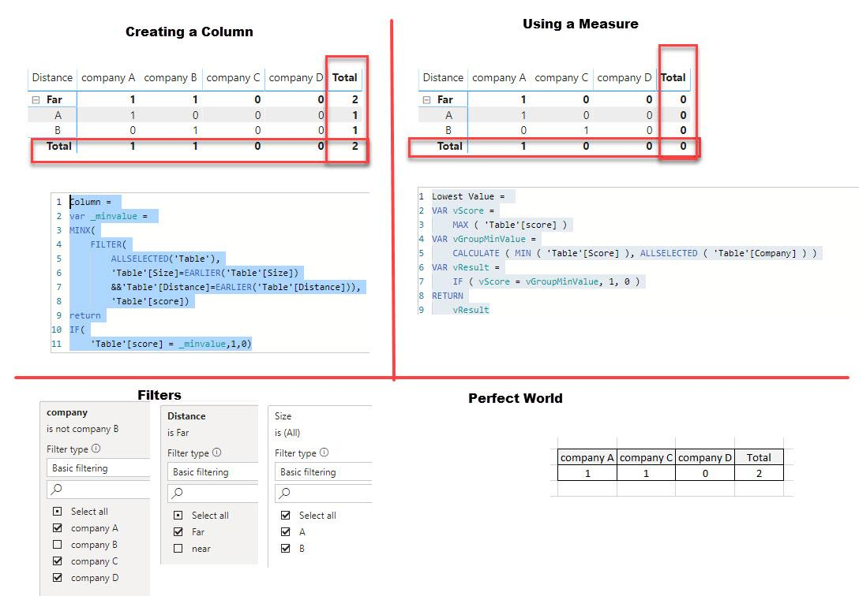
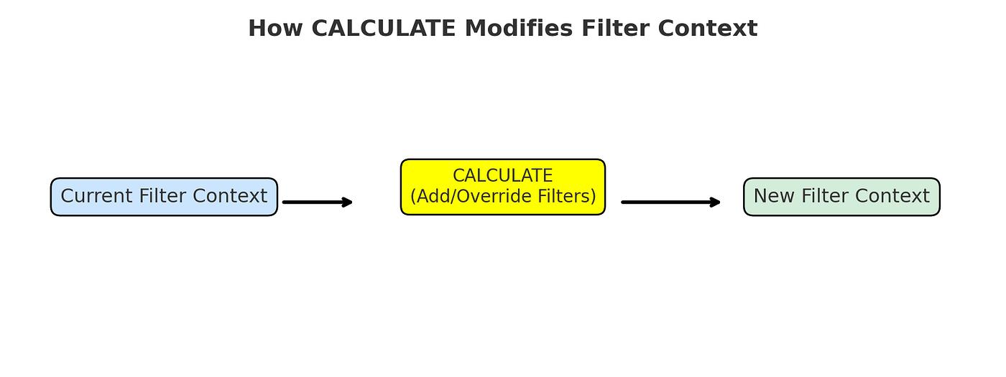
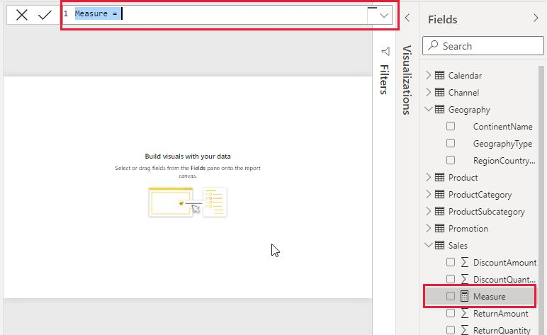

2. FILTER Function
What is FILTER?
Returns a filtered table based on conditions.
Syntax
FILTER(Table, Condition)
Example
Sales above 20,000:
High Sales =
CALCULATE(
SUM(Orders[Sales]),
FILTER(
Orders,
Sales[Sales] > 20000
)
)
Steps
- Create Measure
- Use FILTER inside CALCULATE
- Apply condition
- Use in Card/Table visual

3. ALL Function
What is ALL?
Removes filters from a table or column.
Example
Percentage of Total Sales:
Sales % =
DIVIDE(
SUM(Orders[Sales]),
CALCULATE(
SUM(Orders[Sales]),
ALL(Sales)
)
)
Result
Even if a slicer filters data, ALL returns total sales of the entire table.
Diagram
Category Filter Applied
↓
Current Sales = 50,000
ALL(Sales)
↓
Total Sales = 95,000

4. ALLEXCEPT Function
What is ALLEXCEPT?
Removes all filters except specified columns.
Syntax
ALLEXCEPT(Table, Column)
Example
Category Total =
CALCULATE(
SUM(Orders[Sales]),
ALLEXCEPT(
Orders,
Orders[Category]
)
)
Use Case
Keep Category filter but ignore Product filter.
Category | Product | Sales
Electronics | Laptop | 50000
Electronics | Mobile | 30000
Result = 80,000

5. Context (Row Context vs Filter Context)
Understanding context is critical in DAX.

Row Context
Works row by row.
Example
Calculated Column
Go to Modeling → New Column and use:
Profit =
Sales[Sales] - Sales[Cost]
Power BI calculates for each row individually.
Sales | Cost | Profit
1000 | 600 | 400
1500 | 800 | 700
Diagram
Row 1 → Calculate
Row 2 → Calculate
Row 3 → Calculate

Filter Context
Created by:
- Slicers
- Filters
- Visuals
- CALCULATE()
Example
If user selects:
Category = Electronics
All visuals show Electronics data only.
Diagram
Slicer
↓
Electronics
↓
All Visuals Updated
Visual Representation

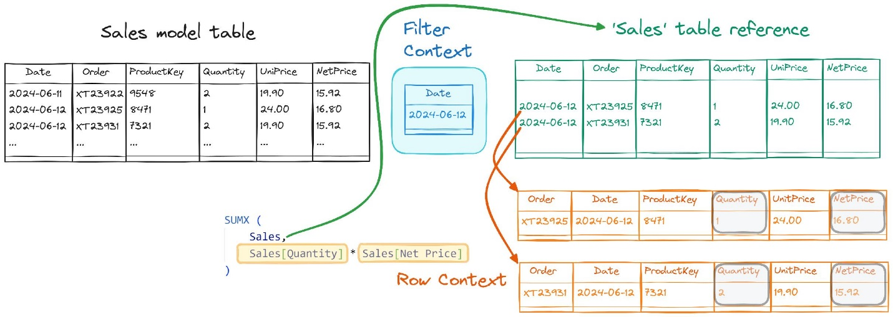
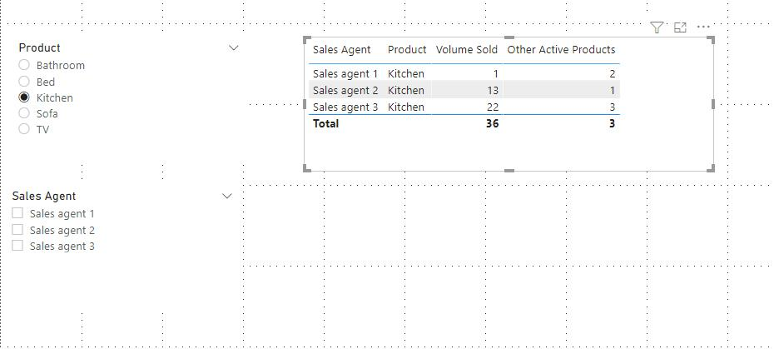

6. Variables (VAR)
What is VAR?
Stores values temporarily and improves performance and readability.
Syntax
VAR VariableName = Value
RETURN Expression
Example
Profit Margin =
VAR TotalSales =
SUM(Sales[Sales])
VAR TotalProfit =
SUM(Sales[Profit])
RETURN =
DIVIDE(
TotalProfit,
TotalSales
)
Benefits
✅ Faster calculations
✅ Easy debugging
✅ Cleaner code
✅ Reusable values
Steps
- Create Measure
- Declare variables using VAR
- Return result using RETURN

7. Measures vs Calculated Columns
Feature | Measure | Calculated Column
Stored in memory | No | Yes
Calculated when | Query time | Data refresh
Uses Filter Context | Yes | No
Uses Row Context | No | Yes
Recommended for KPIs | Yes | No
File Size Impact | Low | High

Measure Example
Total Sales =
SUM(Orders[Sales])
Used in:
- Cards
- Charts
- KPIs
- Dashboards

Calculated Column Example
Profit =
Sales[Sales] - Sales[Cost]
Creates a new column in the table.

When to Use Measures?
✔ Total Sales
✔ Profit %
✔ Running Total
✔ Dynamic KPIs
✔ Dashboard Calculations

When to Use Calculated Columns?
✔ Categories
✔ Flags
✔ Age Groups
✔ Product Segments
✔ Custom Sorting

Interview Questions
Q1. Why is CALCULATE considered the heart of DAX?
Because it changes filter context and evaluates expressions dynamically.
Q2. Difference between ALL and ALLEXCEPT?
- ALL → Removes every filter.
- ALLEXCEPT → Keeps specified filters and removes the rest.
Q3. What is Row Context?
Calculation performed one row at a time.
Q4. What is Filter Context?
Filters applied through visuals, slicers, or DAX functions.
Q5. Why use VAR?
To improve performance, readability, and maintainability of DAX code.
Q6. Measure vs Calculated Column?
Measures are dynamic and calculated at query time; calculated columns are stored in the model and calculated during data refresh.

